1KE4 -

Functionality
The assignment monitor provides you with an overview of all the assignments you have made for various objects, and supports you when you make or change assignments.
You can call up an overview list of:
- Non-assigned objects of a given object type,
- Objects of a given type, which have been assigned to a particular profit center.
Incorrect assignments lead to incorrect transaction data in Profit Center Accounting, which usually can only be corrected with great difficulty. You should therefore check your assignments very carefully.

Scenario
Run the Assignment Monitor to check assignments of Internal orders, Product Cost Collectors, PM orders, Cost centers, and Materials.

Requirements
None.

Menu Path | Accounting → Controlling → Profit Center Accounting → Master Data → 1KE4 - Assignment Monitor
Transaction Code | 1KE4

1. Double click on 1KE4 - Assignment Monitor.

Profit Center Accounting: Assignment Monitor

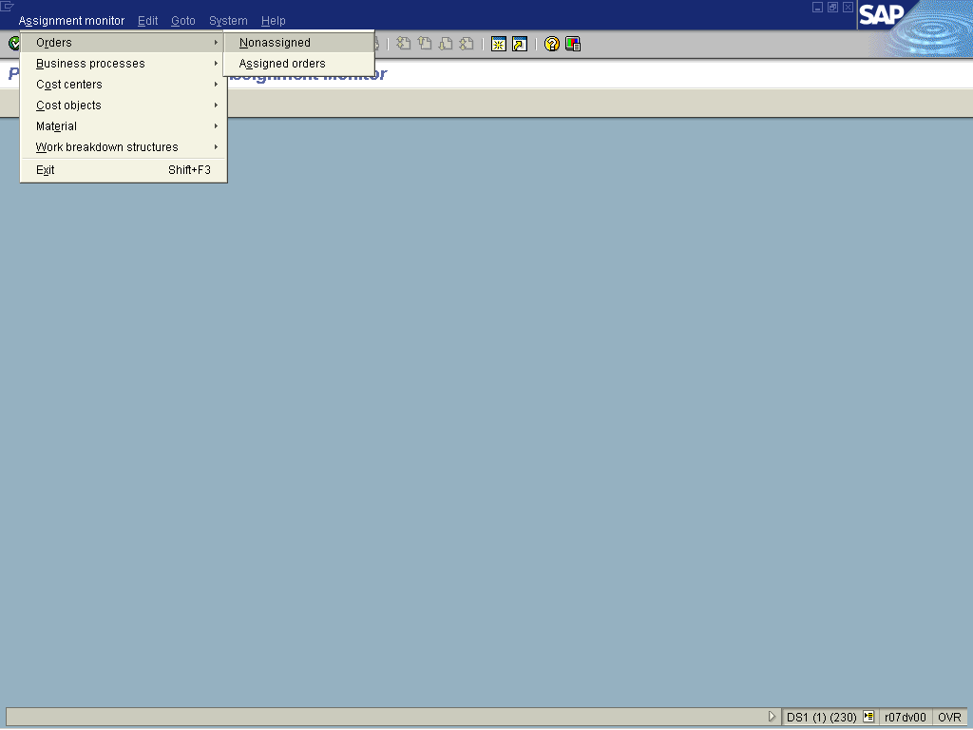

2. To check assignments of Internal orders, select Assignment monitorOrdersNoneassigned.
EC-PCA: Non-Assigned Orders

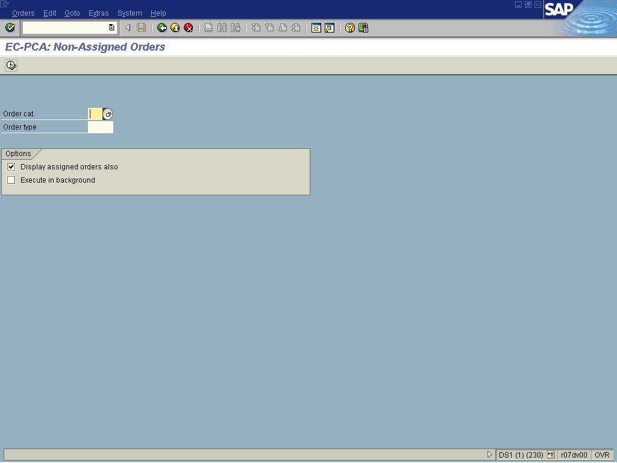

3. Press [F4] or click the Search button in the Order cat field.

Order categories relevant for Profit Center Accounting (1) 9 Entries found

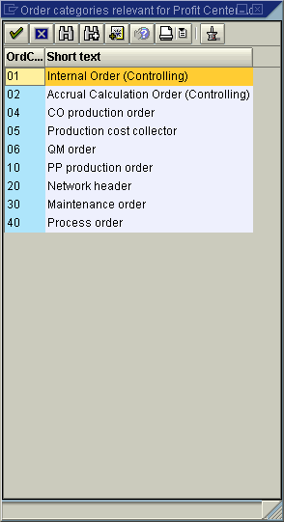

4. Select the 01 - Internal Order (Controlling) in list box.

5. Click the Enter button.

EC-PCA: Non-Assigned Orders

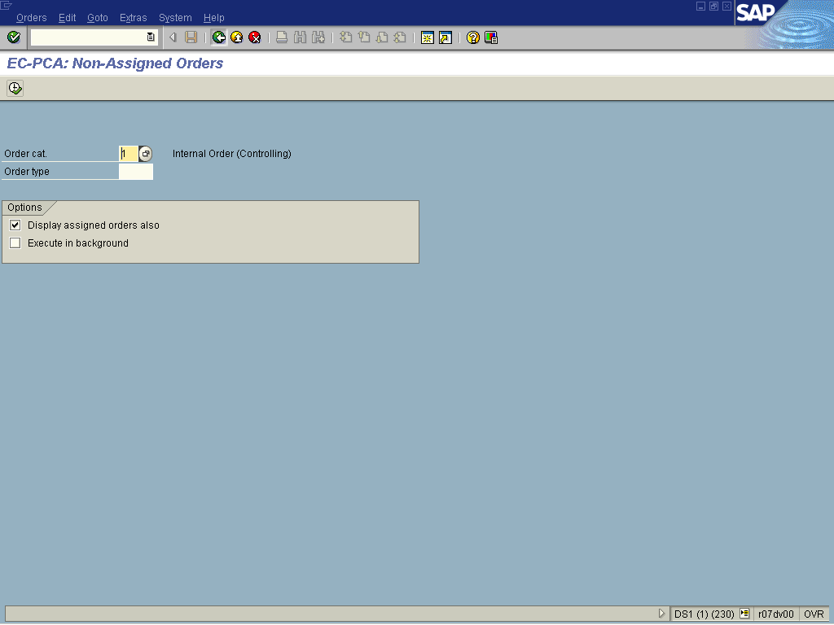

6. Click the Execute button.

EC-PCA: Non-Assigned Orders

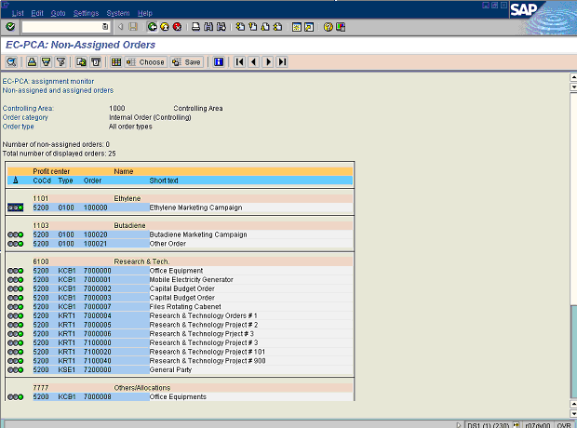

 A "Green light" indicates that the object is assigned, while the "Red light" indicates that it is not.
Tip: You could click on the object and go directly to a master data of an internal order, assuming you have the right authorization.

7. Click the Back button.

EC-PCA: Non-Assigned Orders

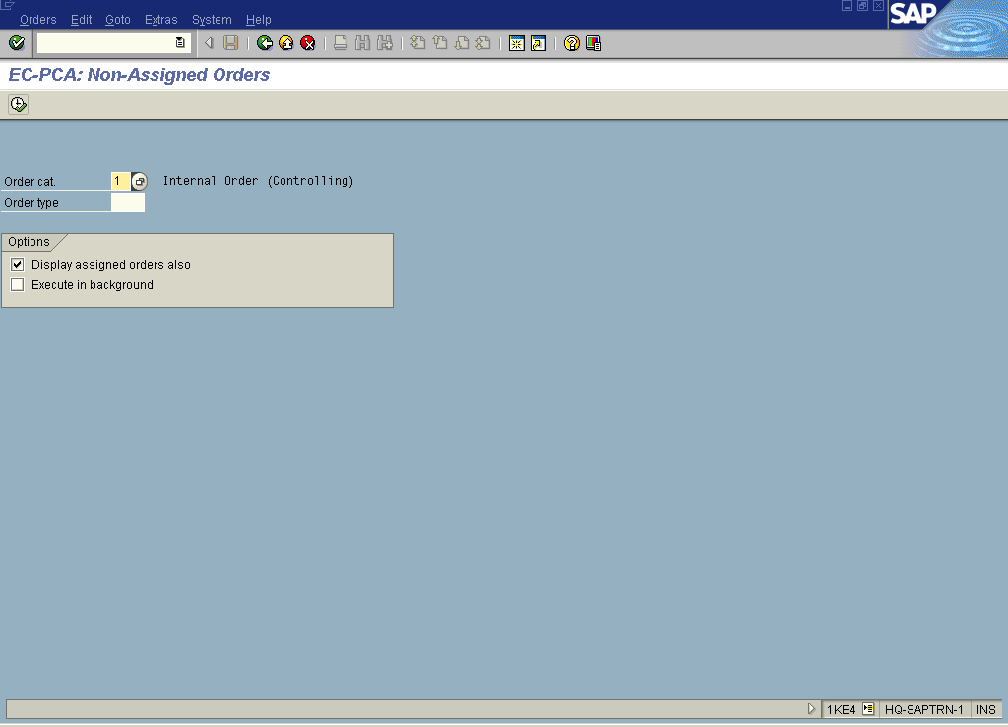

8. Press [F4] or Click the Search button in the Order cat. field.

Order categories relevant for Profit Center Accounting (1) 9 Entries found

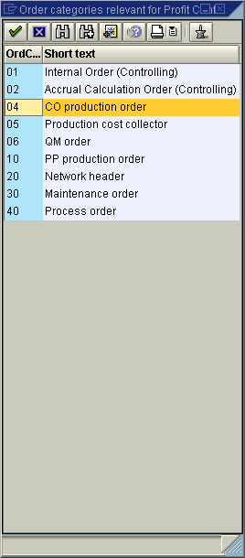

9. Select the 04 – CO production order in list box.

10. Click the Enter button.

EC-PCA: Non-Assigned Orders

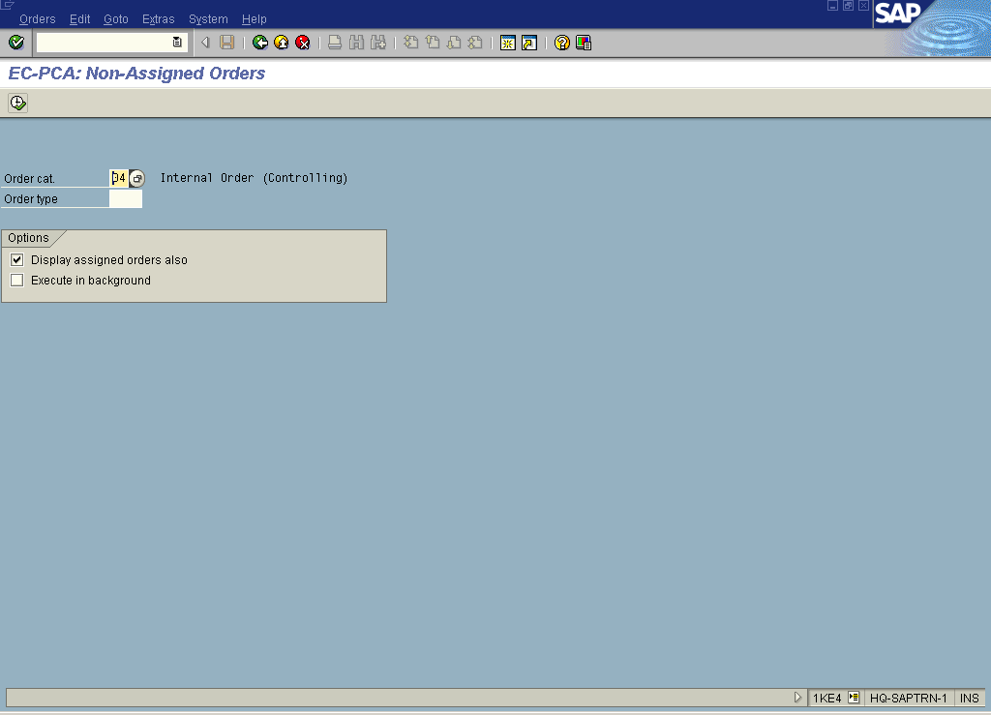

11. Click the Execute button.

EC-PCA: Non-Assigned Orders

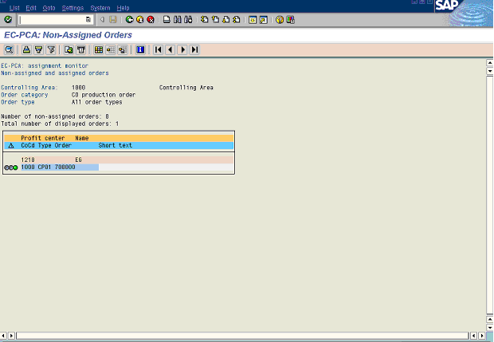

A "Green light" indicates that the object is assigned, while the "Red light" indicates that it is not.
Tip: You could click on the object and go directly to a master data of a CO production order, assuming you have the right authorization.

12. Click the Back button.

EC-PCA: Non-Assigned Orders

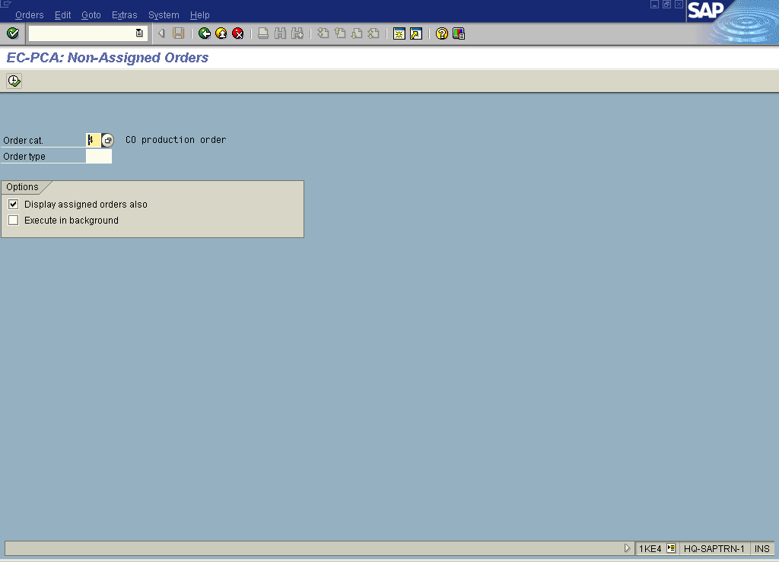

13. Press [F4] or Click the Search button in the Order cat. field.

Order categories relevant for Profit Center Accounting (1) 9 Entries found

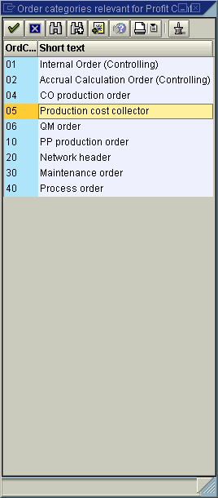

14. Select the 05 – Production cost collector in list box.

15. Click the Enter button.

EC-PCA: Non-Assigned Orders

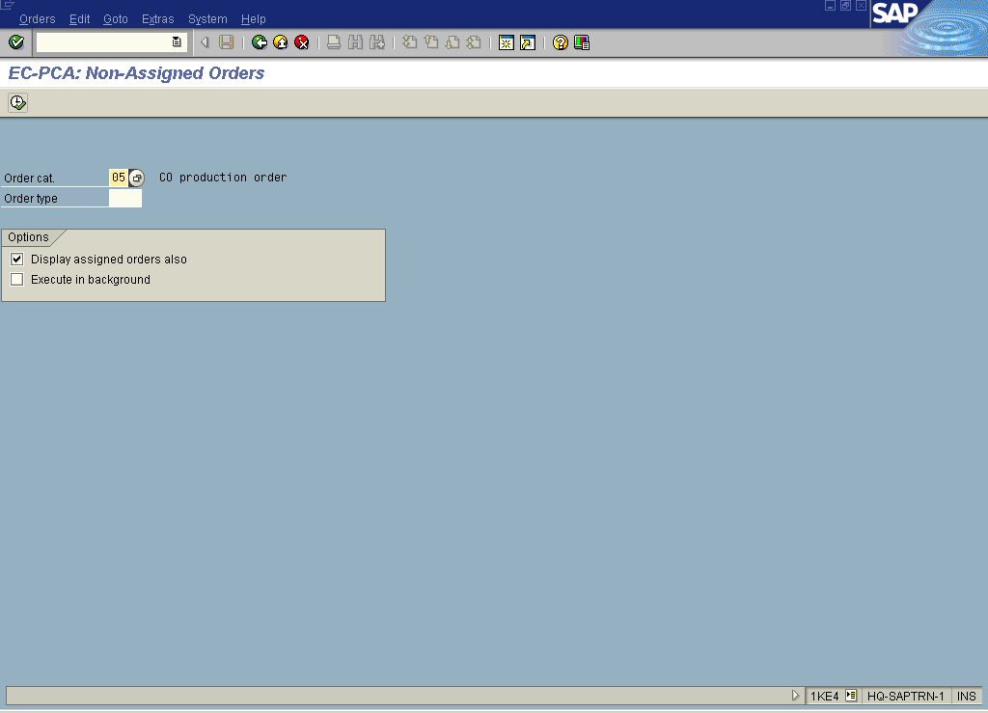

16. Click the Execute button.

EC-PCA: Non-Assigned Orders

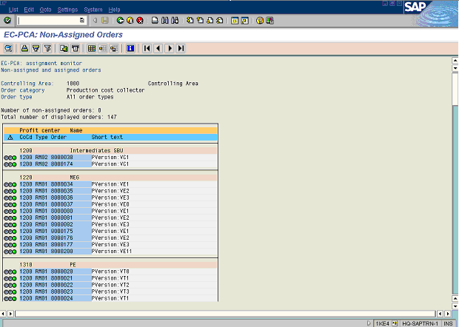

A "Green light" indicates that the object is assigned, while the "Red light" indicates that it is not.
Tip: You could click on the object and go directly to a master data of a Production cost collector, assuming you have the right authorization.

17. Click the Back button.

EC-PCA: Non-Assigned Orders

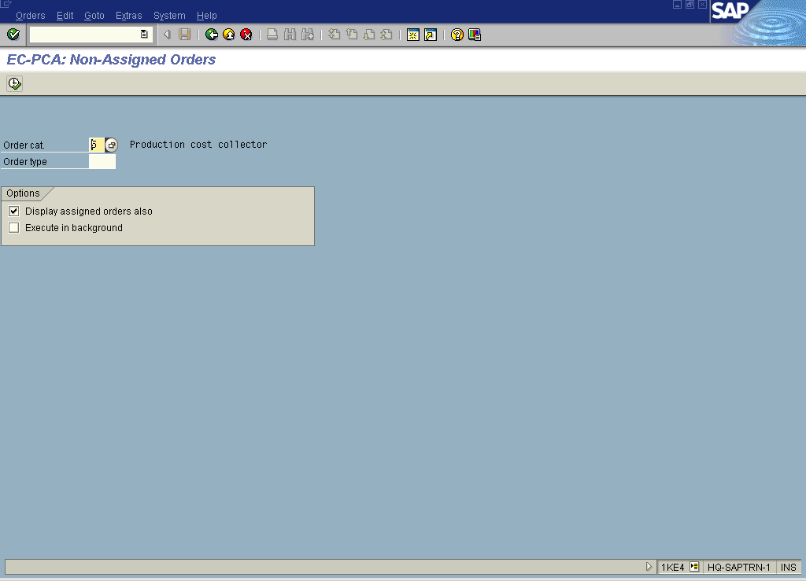

18. Press [F4] or Click the Search button in the Order cat. field.

Order categories relevant for Profit Center Accounting (1) 9 Entries found

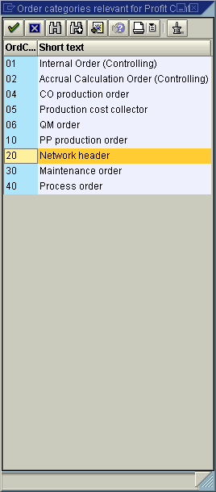

19. Select the 20 – Network header in list box.

20. Click the Enter button.

EC-PCA: Non-Assigned Orders

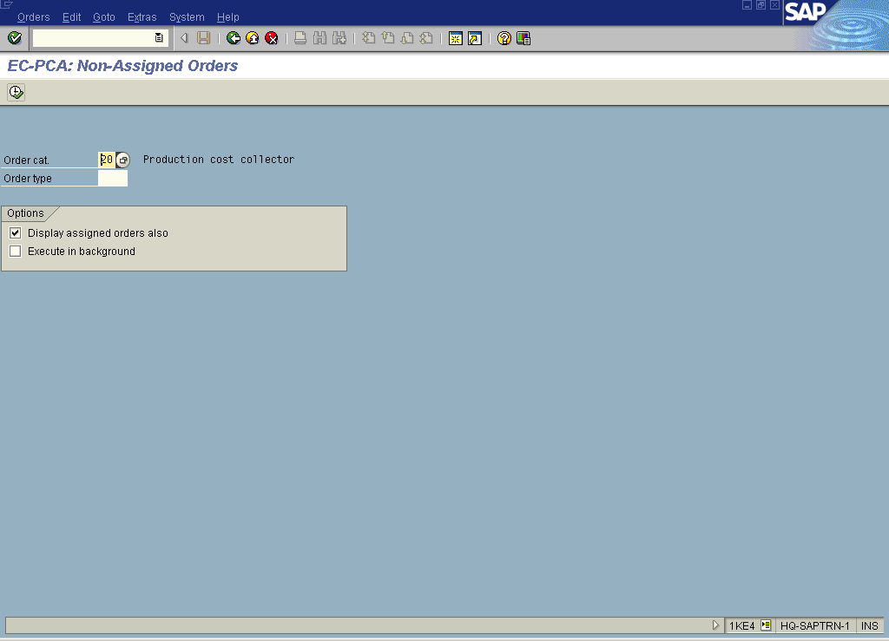

21. Click the Execute button.

EC-PCA: Non-Assigned Orders

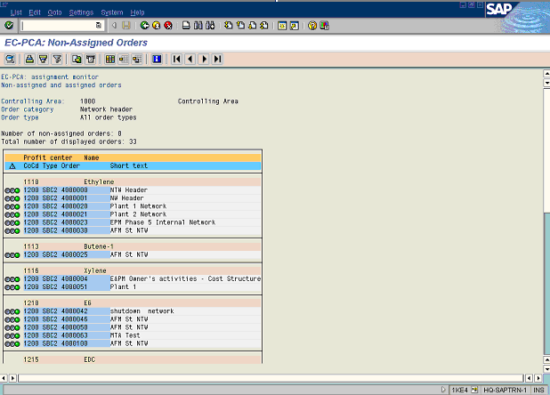

A "Green light" indicates that the object is assigned, while the "Red light" indicates that it is not.
Tip: You could click on the object and go directly to a master data of a Network header, assuming you have the right authorization.

22. Click the Back button.

EC-PCA: Non-Assigned Orders

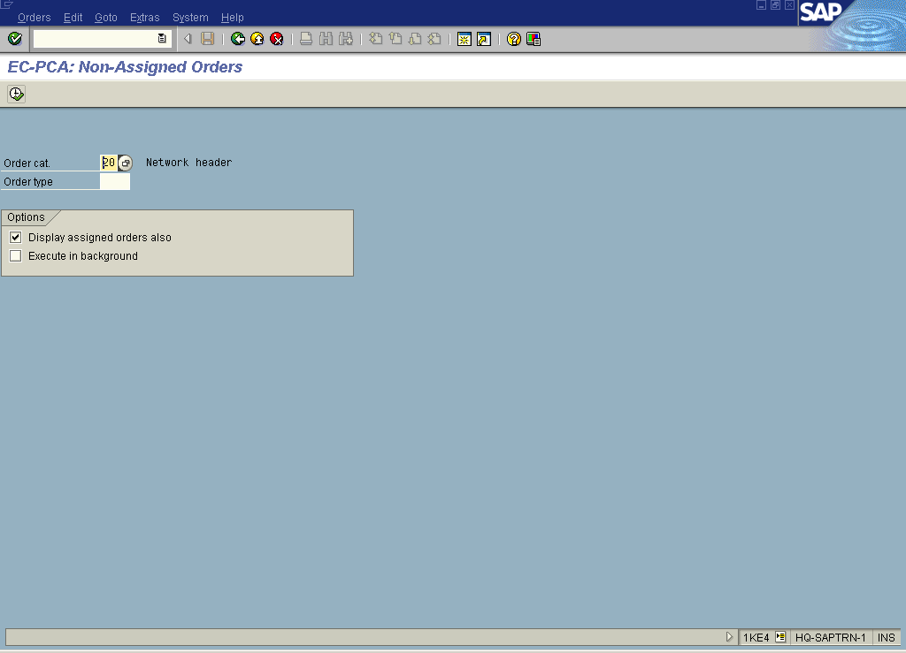

23. Press [F4] or Click the Search button in the Order cat. field.

Order categories relevant for Profit Center Accounting (1) 9 Entries found

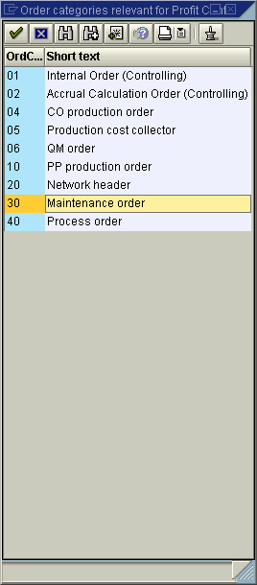

24. Select the 30 – Maintenance order in list box.

25. Click the Enter button.

EC-PCA: Non-Assigned Orders

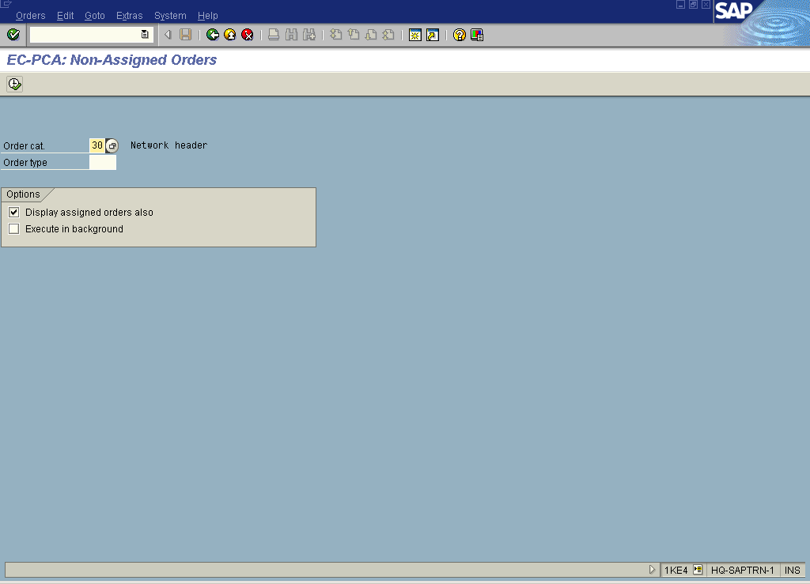

26. Click the Execute button.

EC-PCA: Non-Assigned Orders

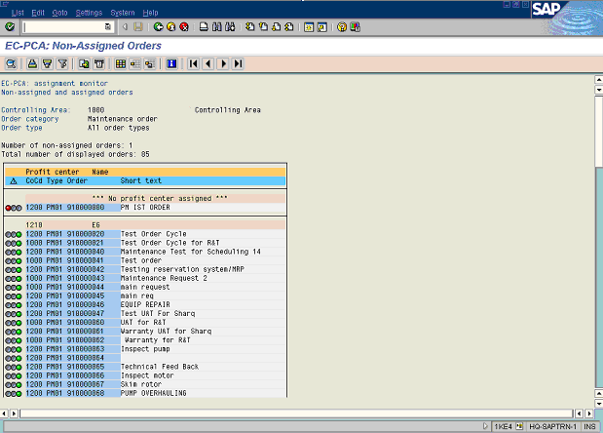

A "Green light" indicates that the object is assigned, while the "Red light" indicates that it is not.
Tip: You could click on the object and go directly to a master data of a Maintenance order, assuming you have the right authorization.

27. Click the Back button.

EC-PCA: Non-Assigned Orders

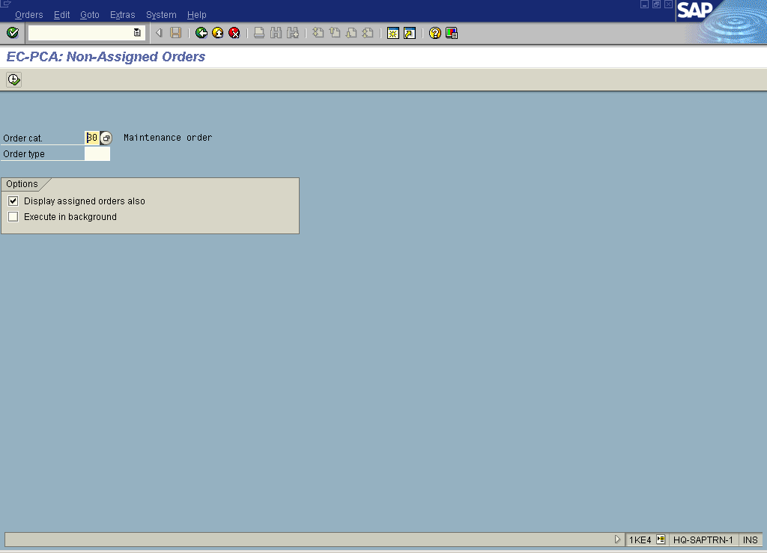

28. Press [F4] or Click the Search button in the Order cat. field.

Order categories relevant for Profit Center Accounting (1) 9 Entries found

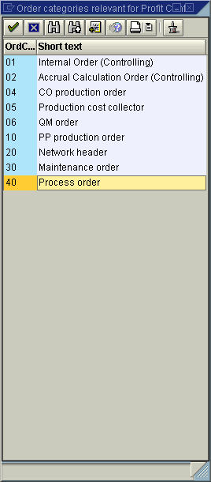

29. Select the 40 – Process order in list box.

30. Click the Enter button.

EC-PCA: Non-Assigned Orders

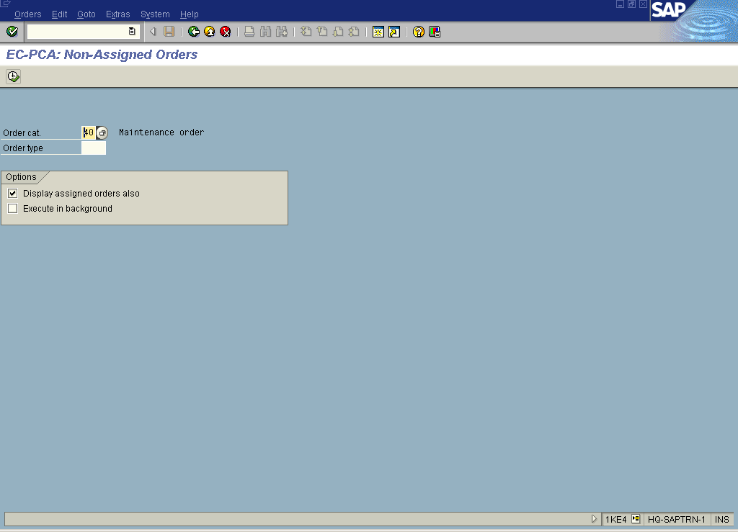

31. Click the Execute button.

EC-PCA: Non-Assigned Orders

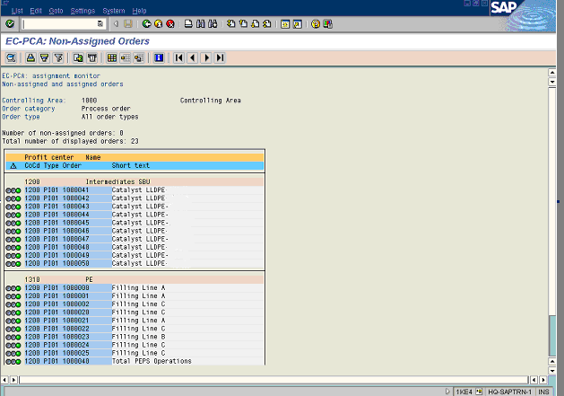

A "Green light" indicates that the object is assigned, while the "Red light" indicates that it is not.
Tip: You could click on the object and go directly to a master data of a Process order, assuming you have the right authorization.

32. Click the Back button.

33. Click the Back button.
Profit Center Accounting: Assignment Monitor

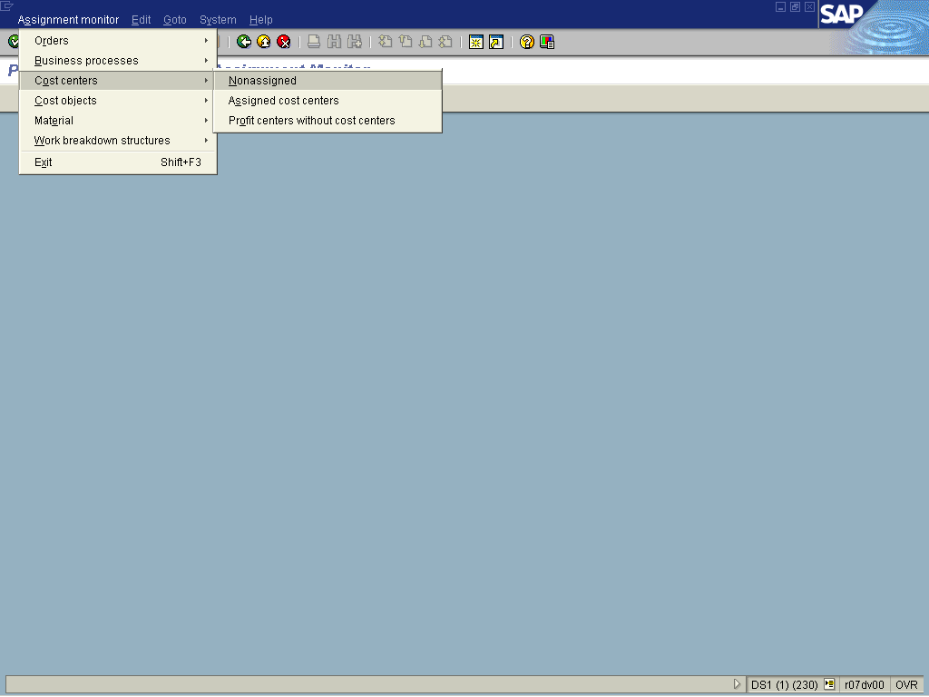

34. To check the assignment of Cost Centers, select Assignment monitorCost centersNoneassigned.

EC-PCA: Non-Assigned Cost Centers

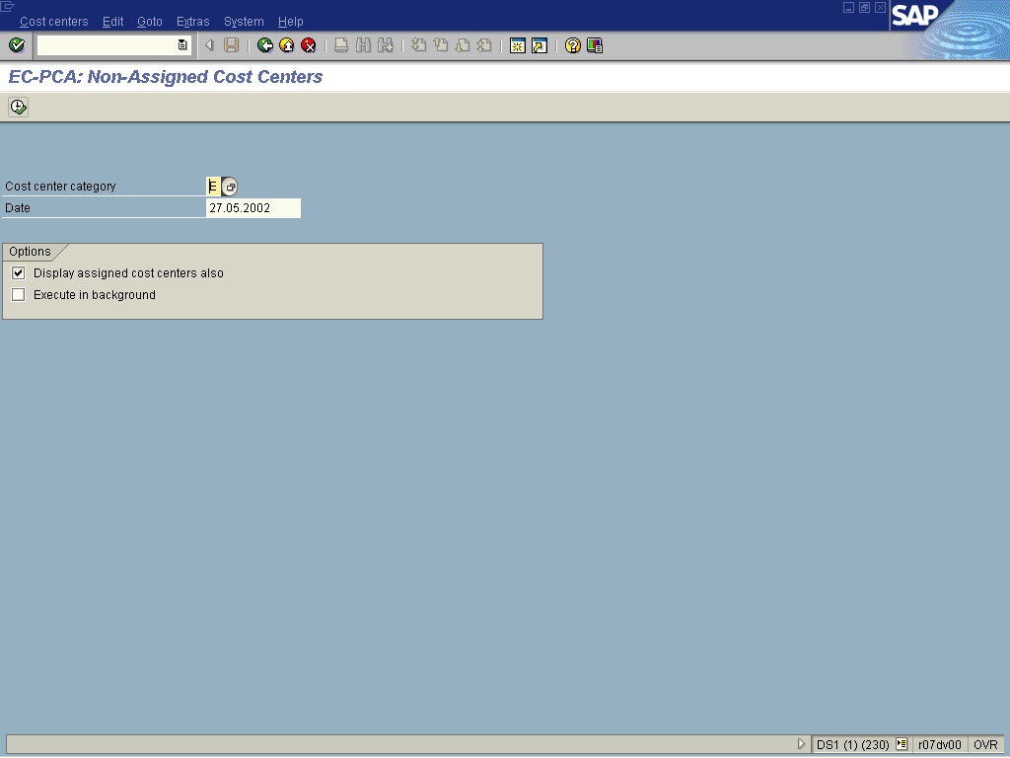

35. Press [F4] or Click the Search button in the Cost center category field.

Restrict value range (1) 18 Entries found

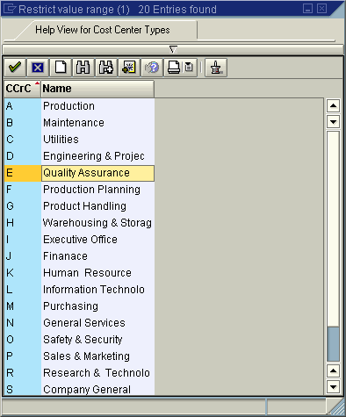

36. Select E – Quality Assurance in list box.
37. Click the Enter button.

EC-PCA: Non-Assigned Cost Centers

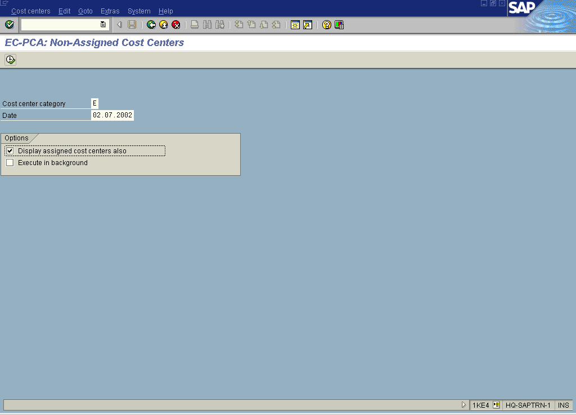

38. Click the Execute button.

EC-PCA: Non-Assigned Cost Centers

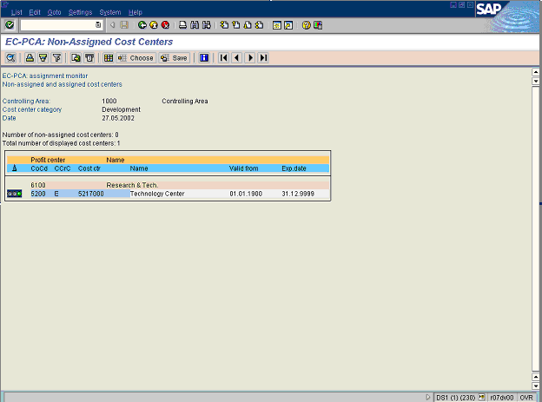

Tip: You could click on the object and go directly to a master data of a Cost center, assuming you have the right authorization.

39. Click the Back button.

40. Click the Back button.

Profit Center Accounting: Assignment Monitor

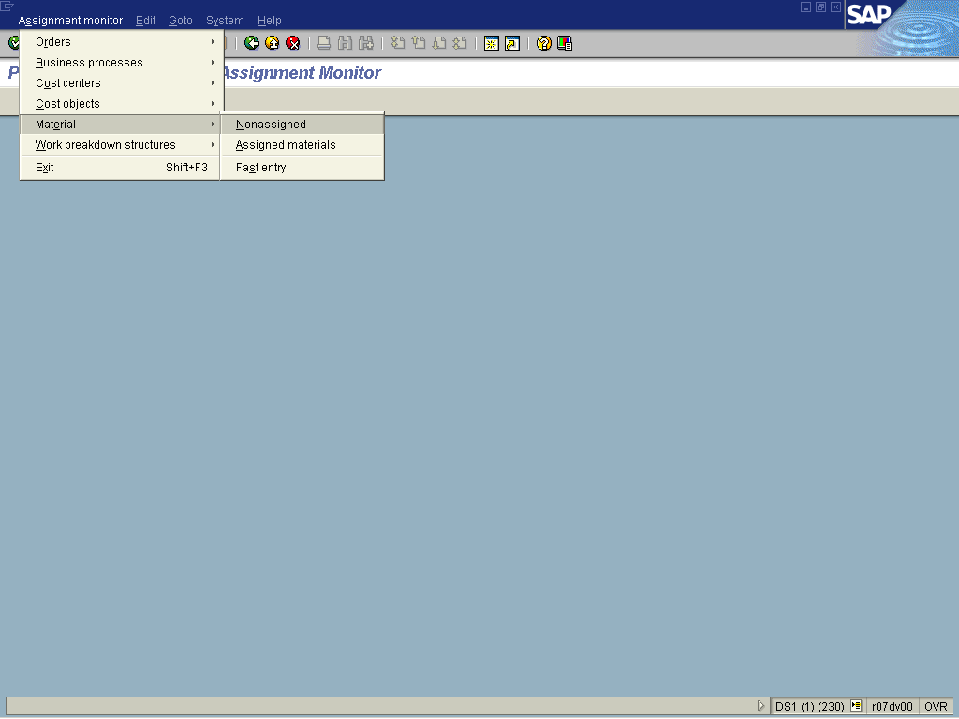

41. To check the assignment of Materials, select Assignment monitorMaterialNoneassigned.

EC-PCA: Non-Assigned Material Numbers

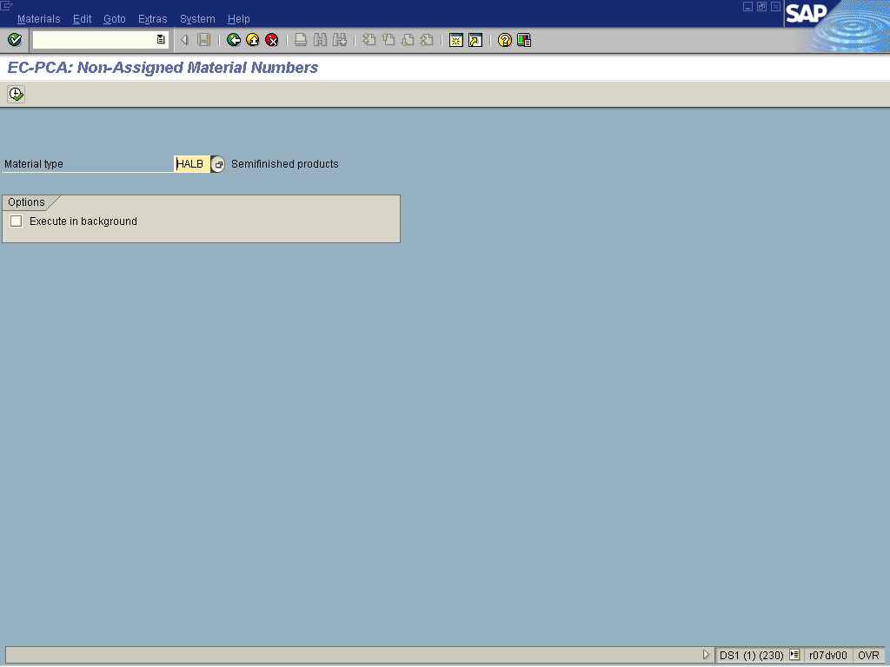

42. Press [F4] or Click the Search button in the Material type field.

Material type (1) 34 Entries found

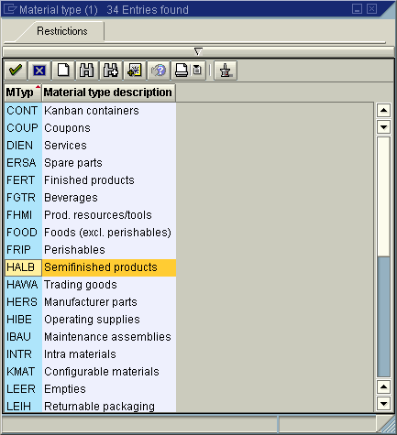

43. Select HALB - Semifinished products in list box.

44. Click the Enter button.

EC-PCA: Non-Assigned Material Numbers

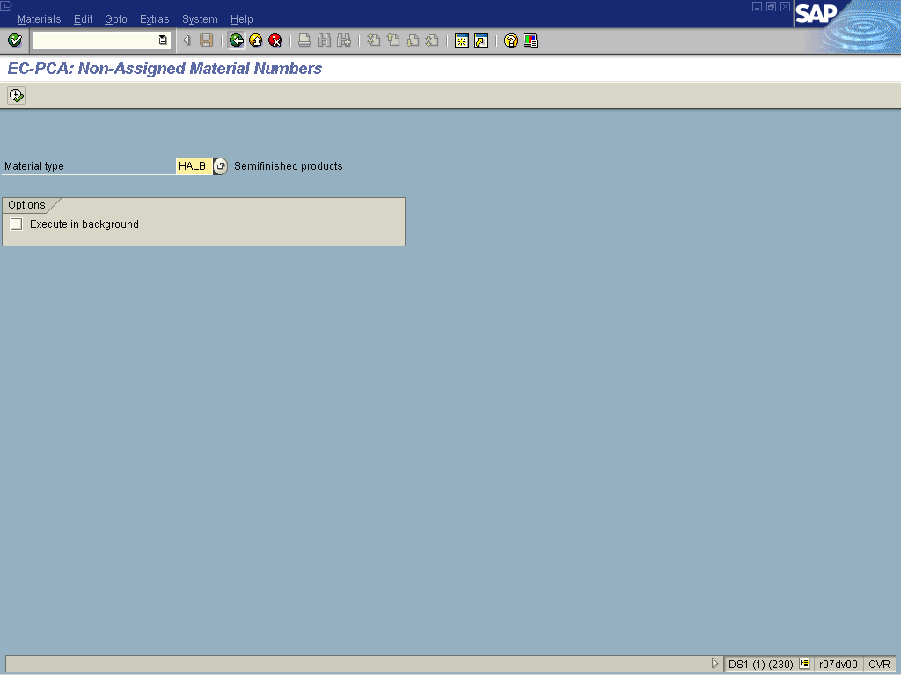

45. Click the Execute button.

EC-PCA: Non-Assigned Material Numbers

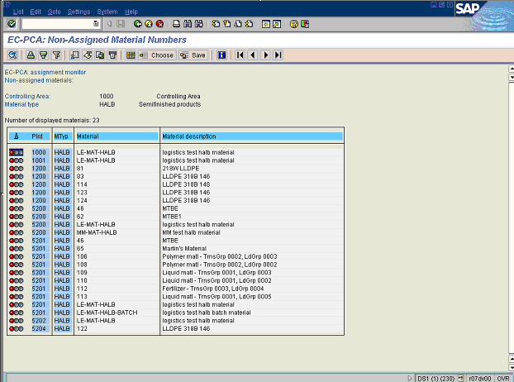

Tip: You could click on the object and go directly to a master data of a Material, assuming you have the right authorization.

46. Click the Back button.

47. Click the Back button.

Profit Center Accounting: Assignment Monitor

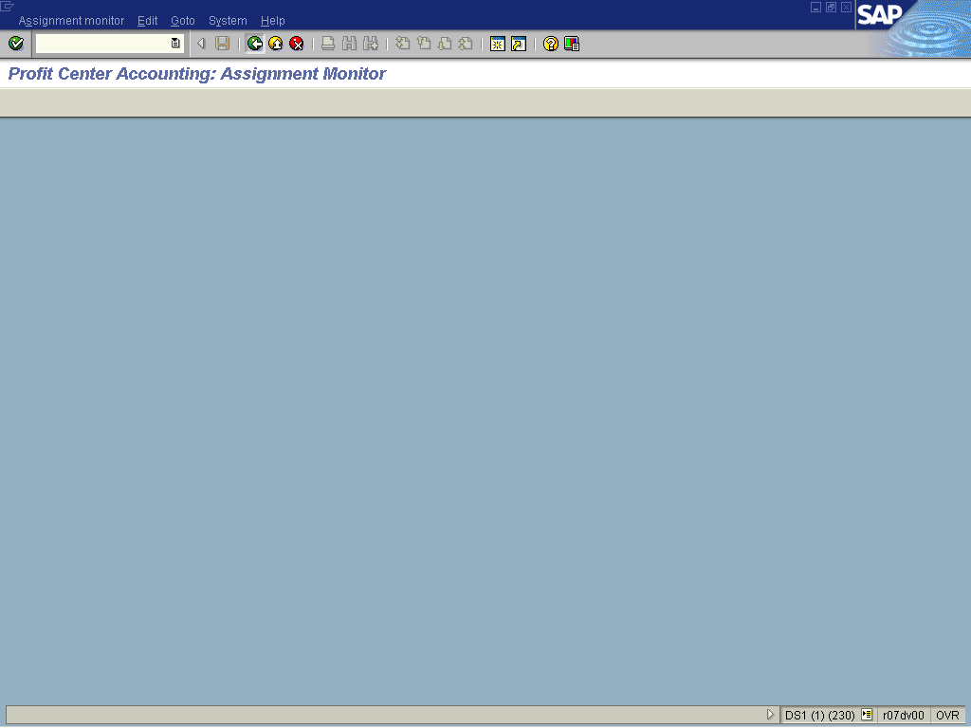

48. Click the Back button to go back to SAP Easy Access screen.

